A MOVIE (1958)

Johanna Gosse (Bryn Mawr)

A Movie (1958) is a twelve-minute compilation montage of vintage newsreels, soft-core “girlie movies,” low-budget Westerns, educational and ethnographic films, and other black-and-white 16mm film ephemera. Filmmaker Bruce Conner selected scenes ranging from the anonymous and slightly absurd—stampeding horses, car crashes, tightrope walkers, half-nude women, and deep sea divers—to more historically specific, even iconic images: the Hindenburg in flames, Teddy Roosevelt orating, the Tacoma bridge collapse of 1940, and most strikingly, the 1946 underwater atomic bomb tests at Bikini Atoll. Using a stopwatch, Conner edited the film to correspond to its orchestral soundtrack, Ottorino Respighi’s 1924 “Pines of Rome,” which lends dramatic intensity and a dash of kitsch to the dream-like spectacle. The imagery is punctuated by misplaced credits that repeatedly announce the film’s title, maker, and “The End” at inappropriate moments, as well as by flickering frames of academy leader and perforated or spoiled film stock, elements that call attention to both the apparatus and to the formulaic conventions of narrative cinema. The lasting influence of Conner’s film is most apparent in contemporary digital media’s recuperation of the radical recombinatory techniques that he pioneered over a half-century ago.

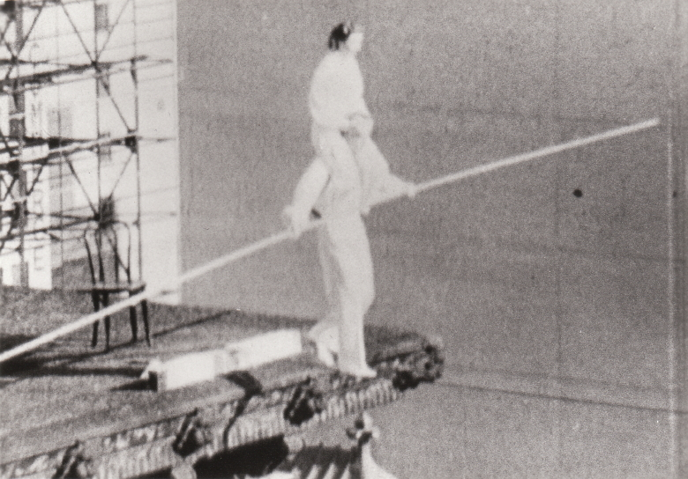

Still from Bruce Conner, A MOVIE (1958)

Further Reading

Hatch, Kevin. (2012) Looking for Bruce Conner, Cambridge, MA: The MIT Press.

Jenkins, Bruce. (1999) “Explosion in a Film Factory: The Cinema of Bruce Conner”, 2000 BC: The Bruce Conner Story, Peter Boswell, Bruce Jenkins, and Joan Rothfuss, eds. Minneapolis, MN: Walker Art Center: 185-223.

MacDonald, Scott. (1988) “Bruce Conner”, A Critical Cinema: Interviews with American Independent Filmmakers, Vol. V, Berkeley, CA: University of California Press: 244–256.
Wees, William C. (1993) Recycled Images: The Art and Politics of Found Footage Films, New York: Anthology Film Archives.

